**Hadi Seyed – Computer Graphics Final Project – Spring 2024**

For my final project, I attempted to create 3D model in Blender. I made a furnished house overall. That is a 3D simulation of a full furnished house with two different lights in different location and a camera.

First, I read and practice some techniques, and then I used them in my project.

The tools and techniques that I learned including Translation, Rotation, Scale, Extrude, Loop cut, Render (different types), Proportional editing, Inset face, Draw, Texture map, Texture paint, Modifier, Lighting and shading, Light sources, Animation and simulation, etc. So, I used a lot of tools and techniques to 3D modeling.

Second, I would like to talk about the resources that I did. The most important resources that I used are course materials including Lecture videos, PowerPoint files and then using the related learning videos in Youtube, Linkedin Learning ect.

Finally, I should say that there were some difficulties in insert texture maps, models and a type of rendering that I could overcome on them by related resources that I mentioned before and consulting to professor whenever I faced to them.

You can see the output of my work in the following:

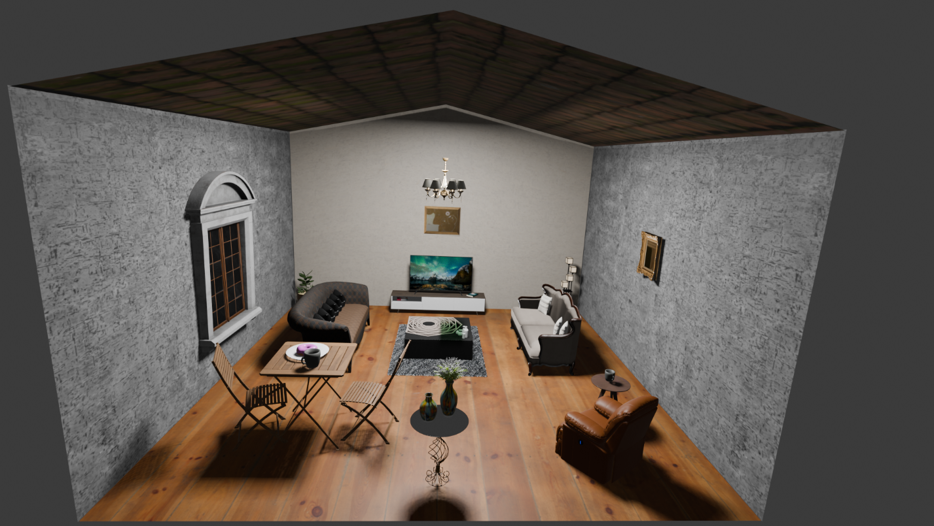

**What are the differences between my Assignment 2 and Final Project:**

I did some thickness to planes and stuffs and made most pieces to one layer rather than some layers.

You can just see the thickness of planes in the following picture. Other pieces are so detailed, and their thickness are not clear in the picture.

Also, due to the 3D printer didn’t able to print the huge files with a lot of details, I had to remove some objects and made one object to one layer not some layers. Because my file was so huge and had a lot of pieces around 167000 and something.

So, I did put the output of original file in this report and printed it out too simpler.

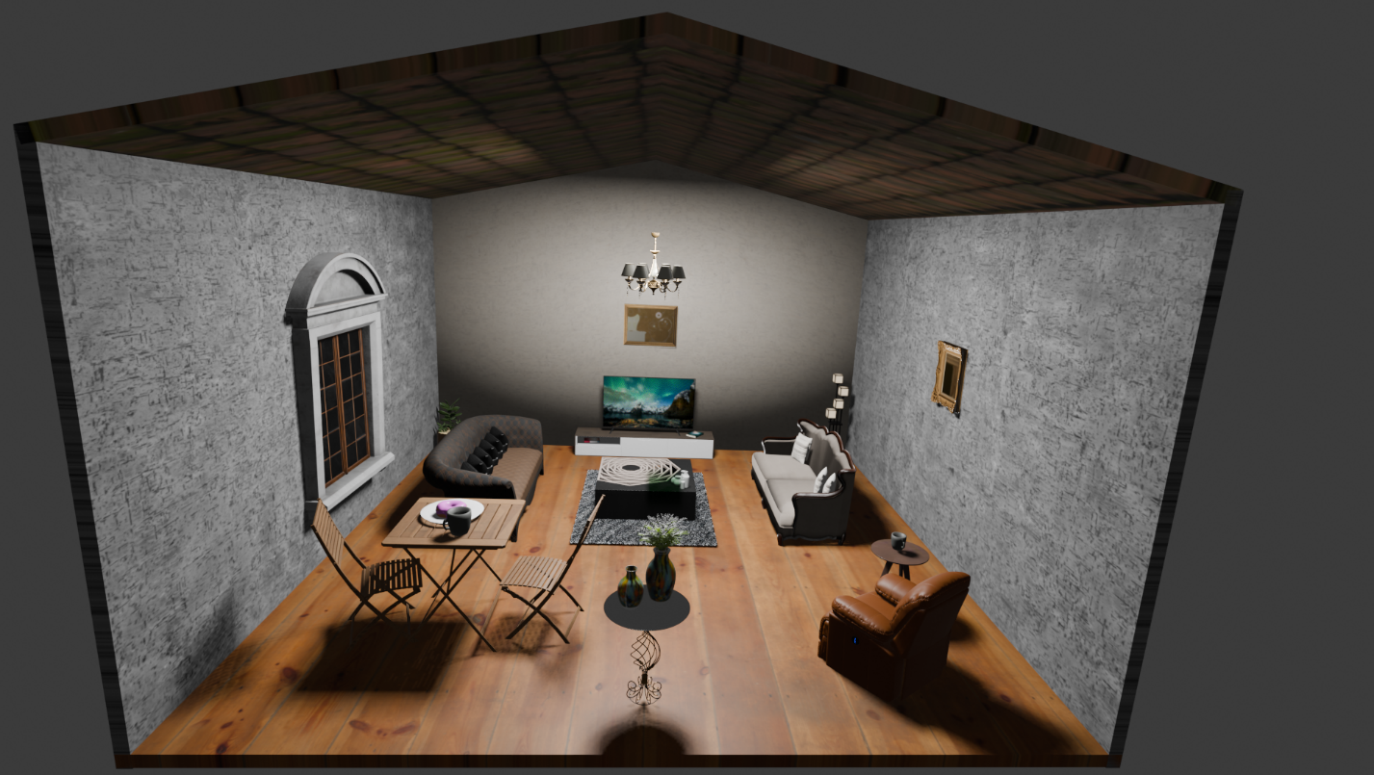

[**Isley Innovation Hub Training**](https://ecu.instructure.com/courses/77874)

I would like to share my experience in training about the printer’s information and materials that you can use to printing with you.

We can print our projects with PLA, PETG and TPU materials. There are 3 kinds of printers in Isley Innovation Hub that you will be able to use. The Prusa printer has Highest precision, Ender printer has Fastest speed and Fusion printer has largest print size. Furthermore, you cannot be printed the NSFW Prints, Weapons, Prop Weapons, Helmets and Board Games. Also, they use 200 grams of filament at maximum for your print, and stl. file is required for a 3D print submission. Finally, you have to pick up a print submission after 2 weeks when it has been completed.